**Vivekananda Institute of Professional Studies** - **Technical Campus**

**(Affiliated to GGSIP University, Delhi, Recognized by AICTE)**

**Vivekananda School of Information Technology**

|  |  |
| --- | --- |
|  |  |

MASTERS OF COMPUTER APPLICATIONS

2023-2025

**MCA - 163**

**PRACTICAL FILE**

**OF**

**Operating System with Linux**

|  |  |
| --- | --- |
| **Submitted To:** | **Submitted By:** |
| **Dr. Neetu Goel** | **Muhammed Raihan P. S.** |
| **Assistant Professor** | **13017704423** |
| **VSIT, VIPS** | **MCA 1C** |

**INDEX**

|  |  |  |  |  |
| --- | --- | --- | --- | --- |
| **S NO** | **TOPIC** | **DATE** | **PAGE NO.** | **SIGN** |
| **1** | Create the flowing new directory structure. |  |  |  |
| **2** | Append the content of f1 file |  |  |  |
| **3** | Merge the f2 and f4 file in f6 file. |  |  |  |
| **4** | Copy f1 and f2 file in the m13 directory using the absolute path. |  |  |  |
| **5** | Copy f6 file in the m4 folder using relative path. |  |  |  |
| **6** | Delete the m6 folder with confirmation using the rmdir command. |  |  |  |
| **7** | Delete the f6 file using absolute path |  |  |  |
| **8** | Copy the whole structure in new folder[any name]& display all files and folder which are copied to the new folder |  |  |  |
| **9** | Try to delete the new folder with confirmation and also display the list of removed files. |  |  |  |
| **10** | Save the whole detail(syntax etc.) Of cp command in new file |  |  |  |
| **11** | Copy this file into the m10 folder |  |  |  |
| **12** | Delete your whole directory structure using a single command |  |  |  |
| **13** | Write a shell script to print addition & subtraction of two numbers. |  |  |  |
| **14** | Write a shell script to print multiplication & division of two numbers. |  |  |  |
| **15** | Perform following function by shell script : D=b+c/a. |  |  |  |
| **16** | Write the shell script to calculate average & percentage of marks entered by user. |  |  |  |
| **17** | Write a shell script to accept 3 numbers from user and find the largest among them. |  |  |  |
| **18** | Write a shell script to print if the number is odd or  even accepted from user. |  |  |  |
| **19** | Write a shell script that computes the gross salary of a employee according To the following rules  if basic salary is < 1500 then HRA=10% of the basic salary and  DA=90% of basic  if basic salary is >=1500 then HRA=Rs 500 and DA=98% of basic The basic salary is accepted from user. |  |  |  |
| **20** | Write a shell script to calculate the grade of student. Take 5 subjects into consideration.  Grade “O” if >= 90%  Grade “A” if >= 75% but less than 90%  Grade “B” if >= 60% but less than 75% Grade “D” if >= 50% but less than 60% Grade “E” if < 50%. |  |  |  |
| **21** | WAP to print Parent and Child process id in c and run it in linux. |  |  |  |
| **22** | WAP to create a process and check whether the process is created or not using if else statements |  |  |  |
| **23** | WAP a nested process using fork() command. |  |  |  |
| **24** | WAP factorial of a number. |  |  |  |
| **25** | WAP sum of first 10 natural numbers. |  |  |  |
| **26** | WAP sum of first 10 input value. |  |  |  |

**1 Create the following new Directory structure**

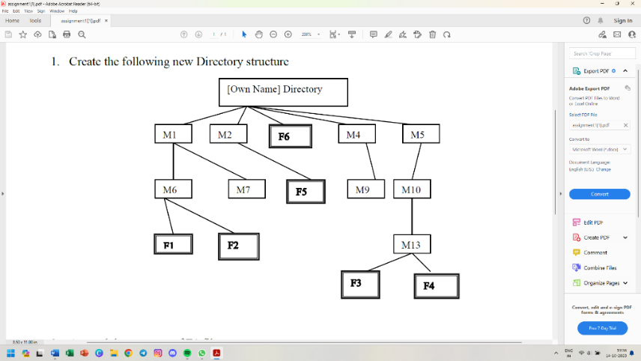

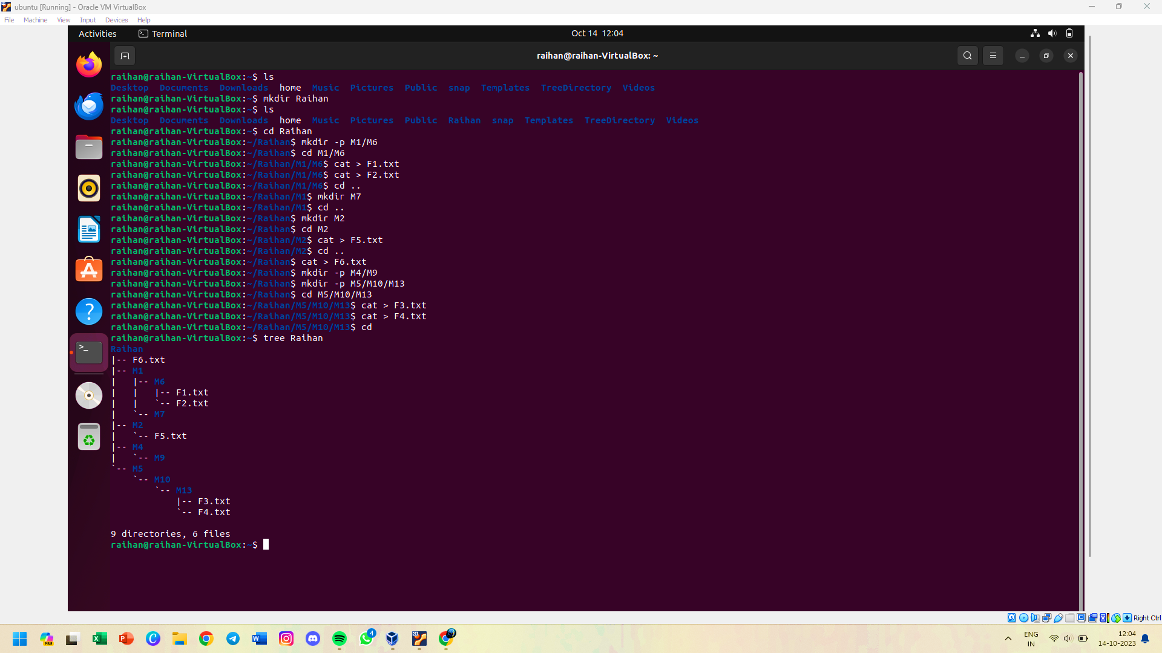

**2 Append the contents of F1 file**

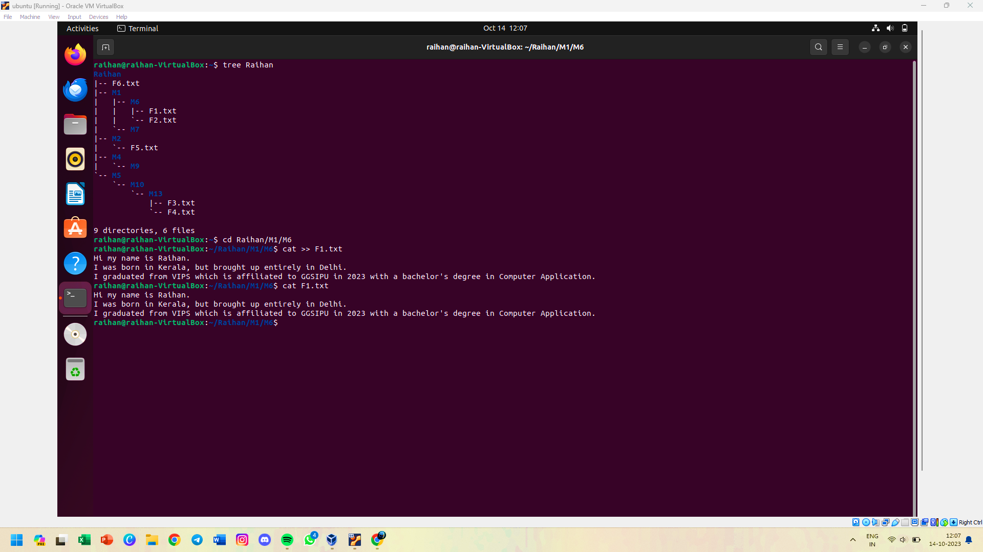

**3 Merge the F2 & F4 file in F6 file**

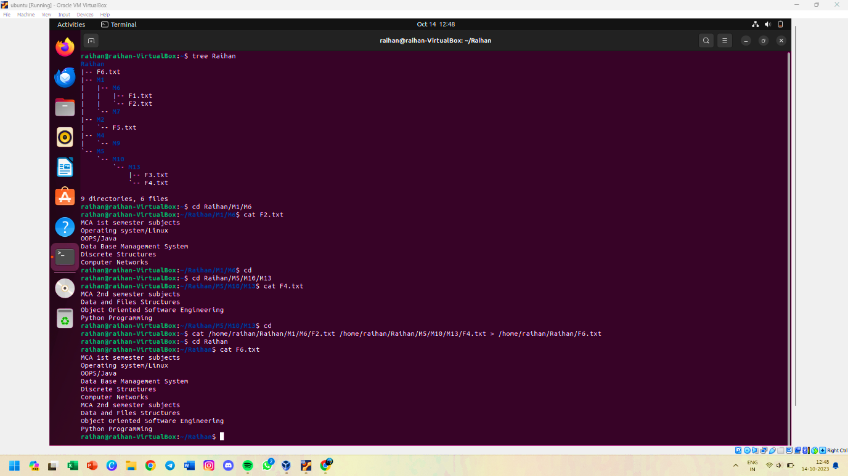

**4 Copy F1 & F2 file in the M13 directory using absolute path**

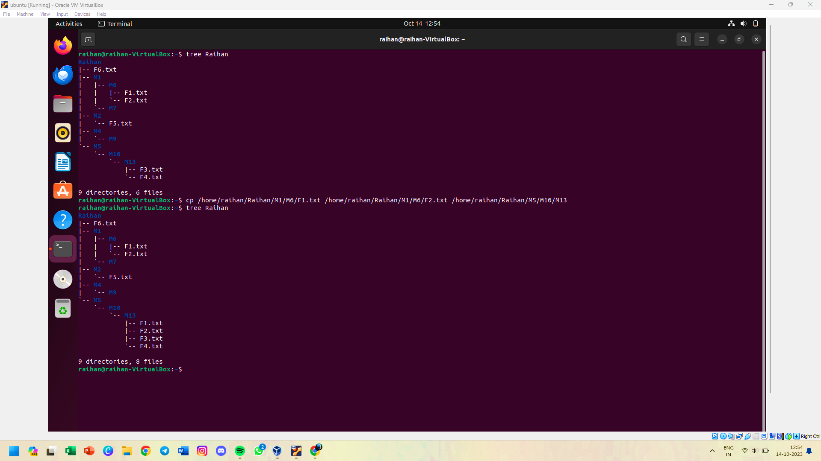

**5 Copy F6 file in the M4 folder using relative path**

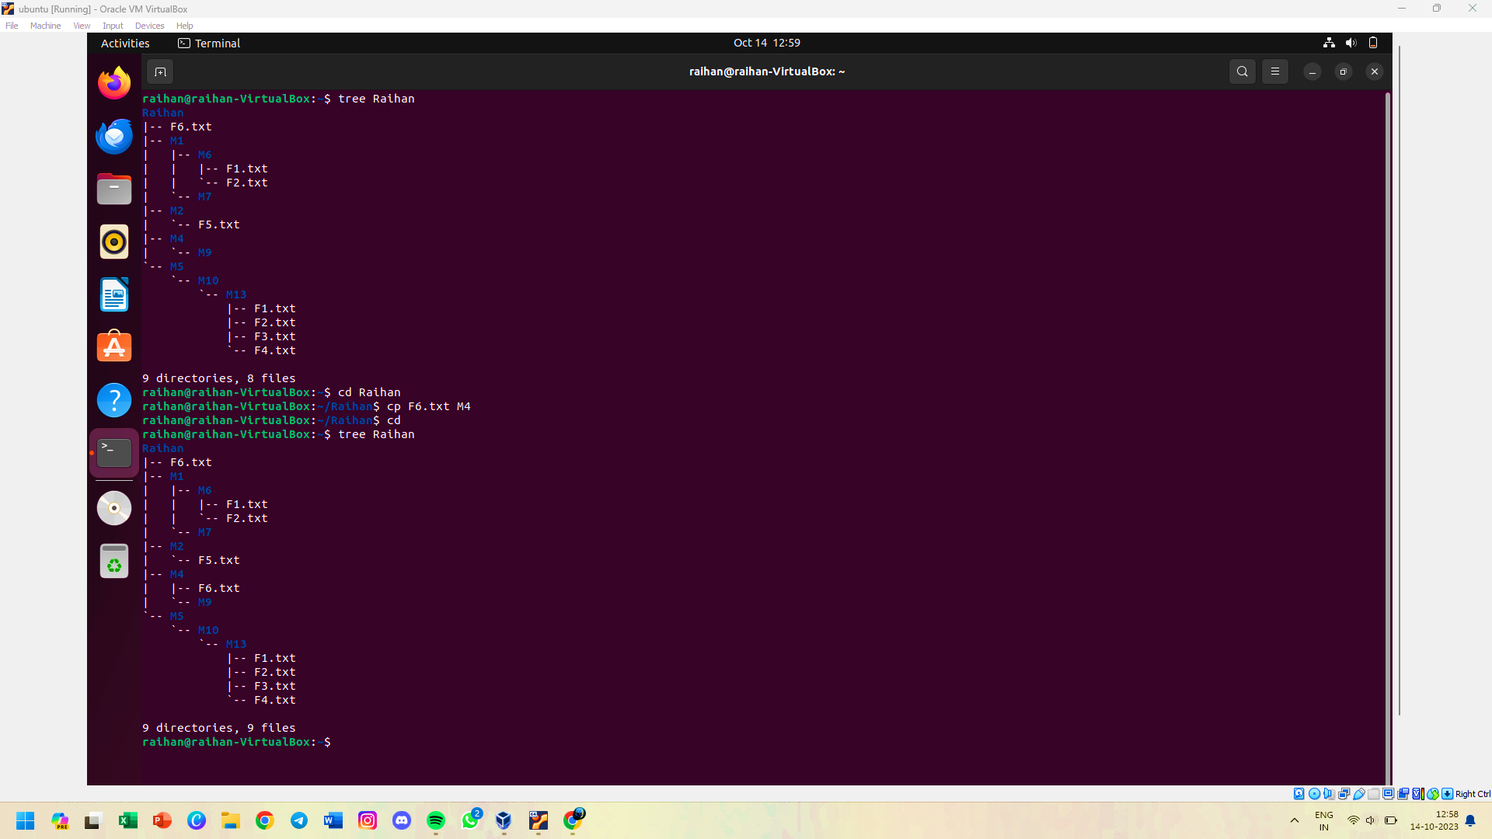

**6 Delete the M6 folder with confirmation using rmdir command**

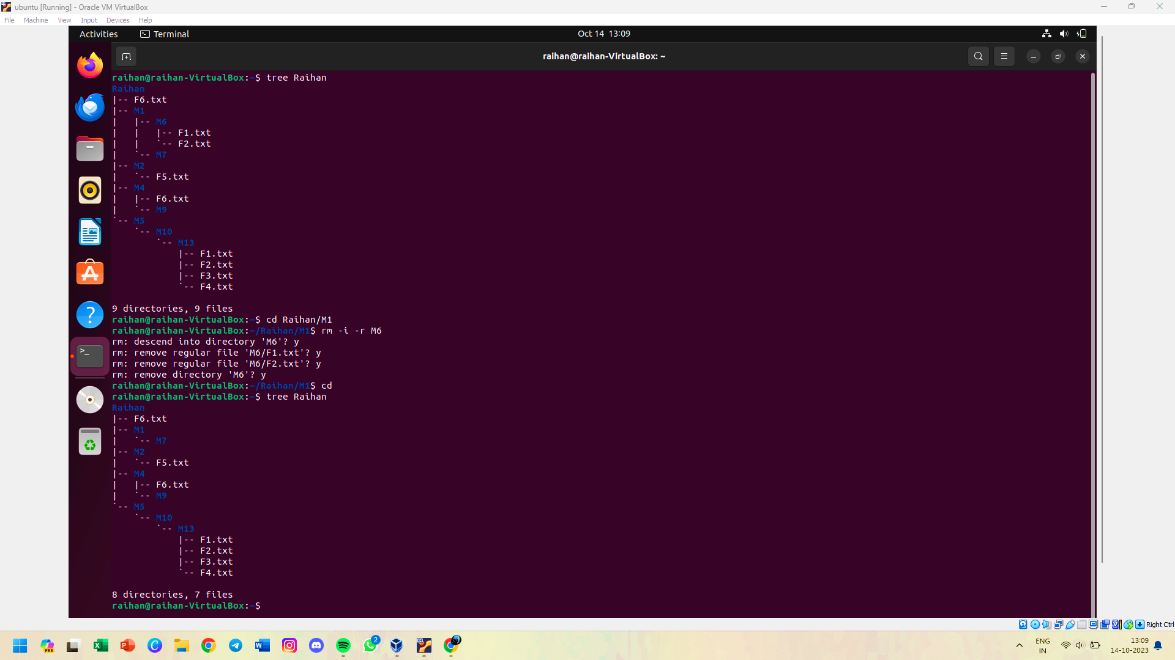

**7 Delete the F6 file using absolute path**

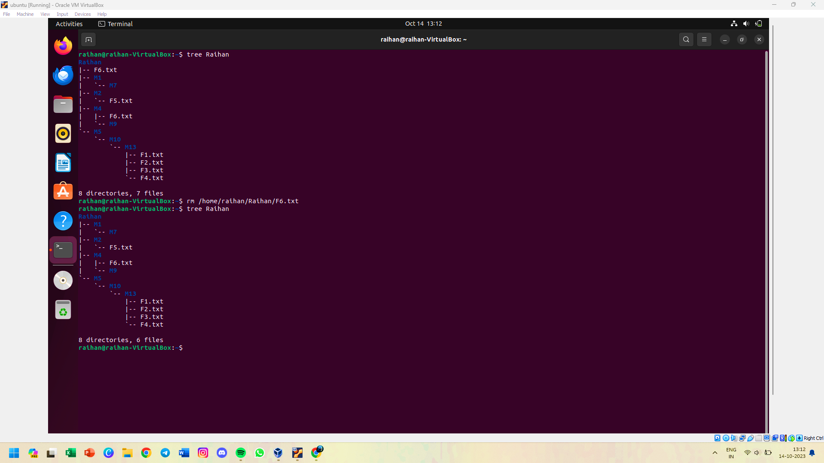

**8 Copy the whole structure in new folder [any name] & display all files and folders which are copied to new folder**

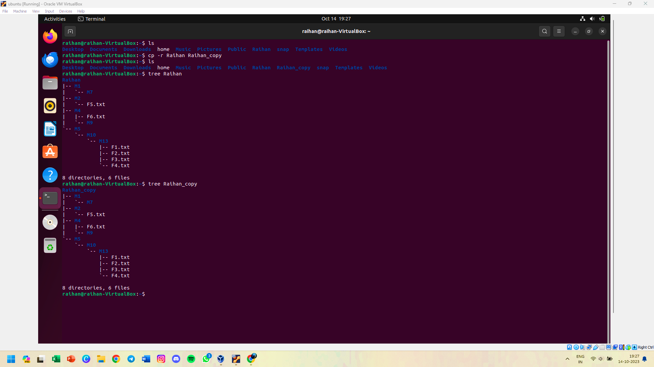

**9 Try to delete the new folder with confirmation and also display the list of removed files**

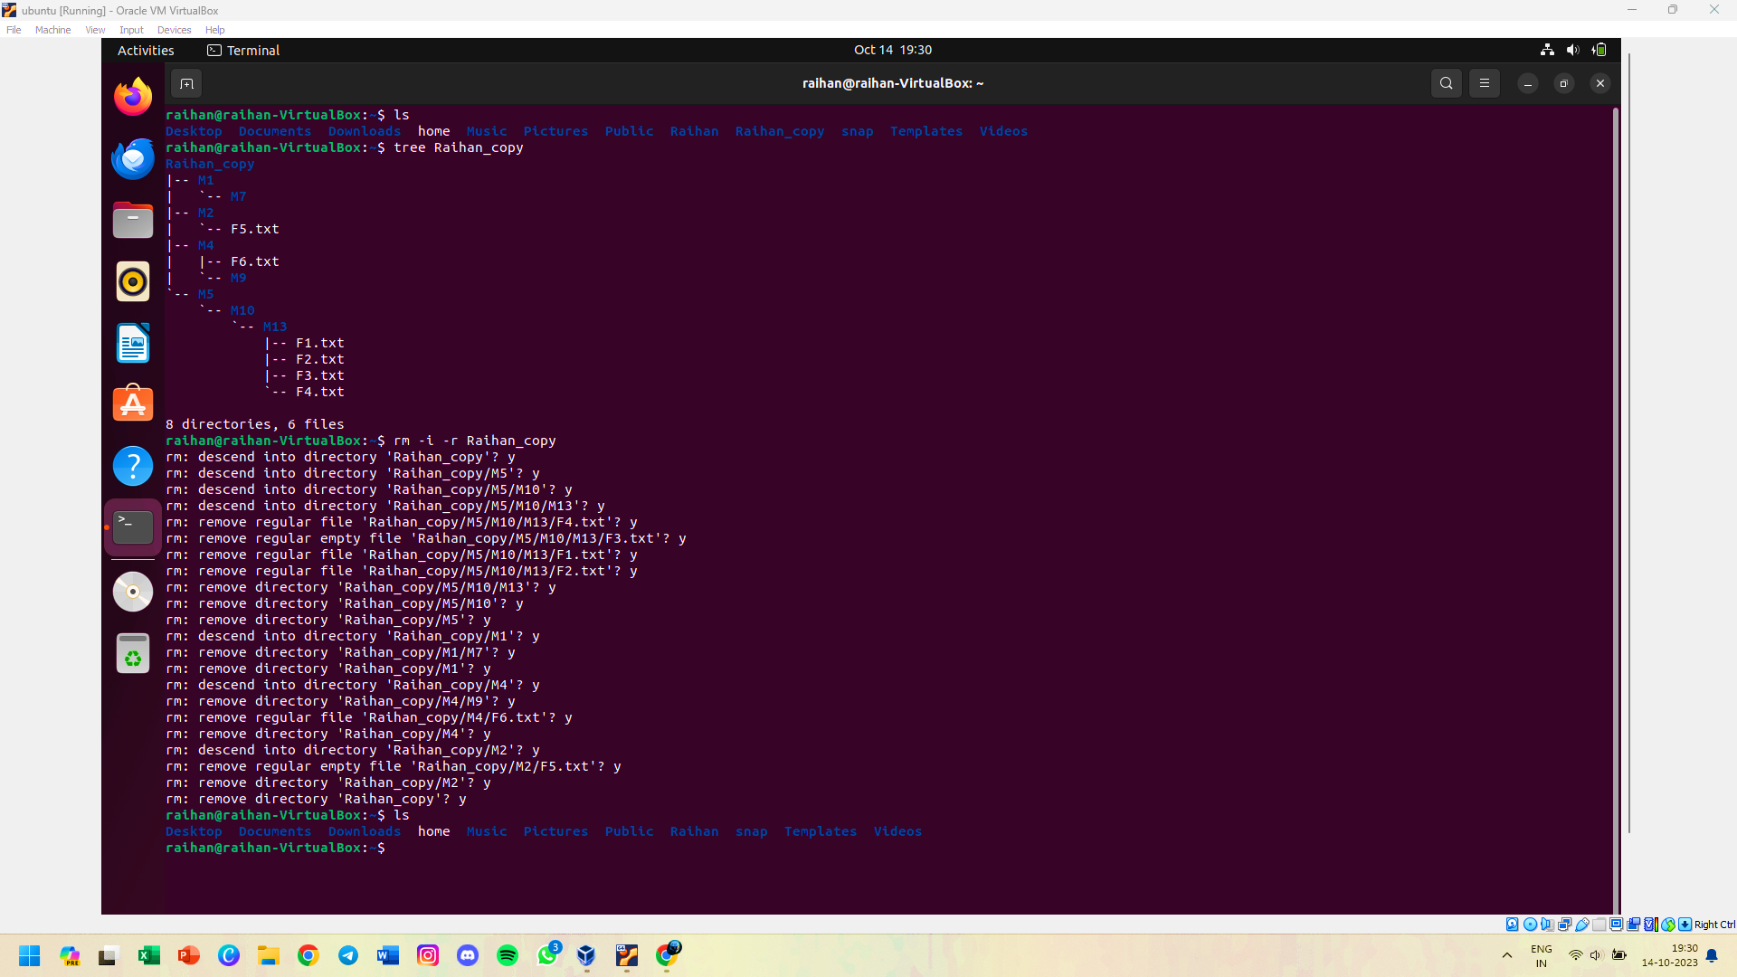

**10 Save the whole detail (syntax etc.) of cp command in new file**

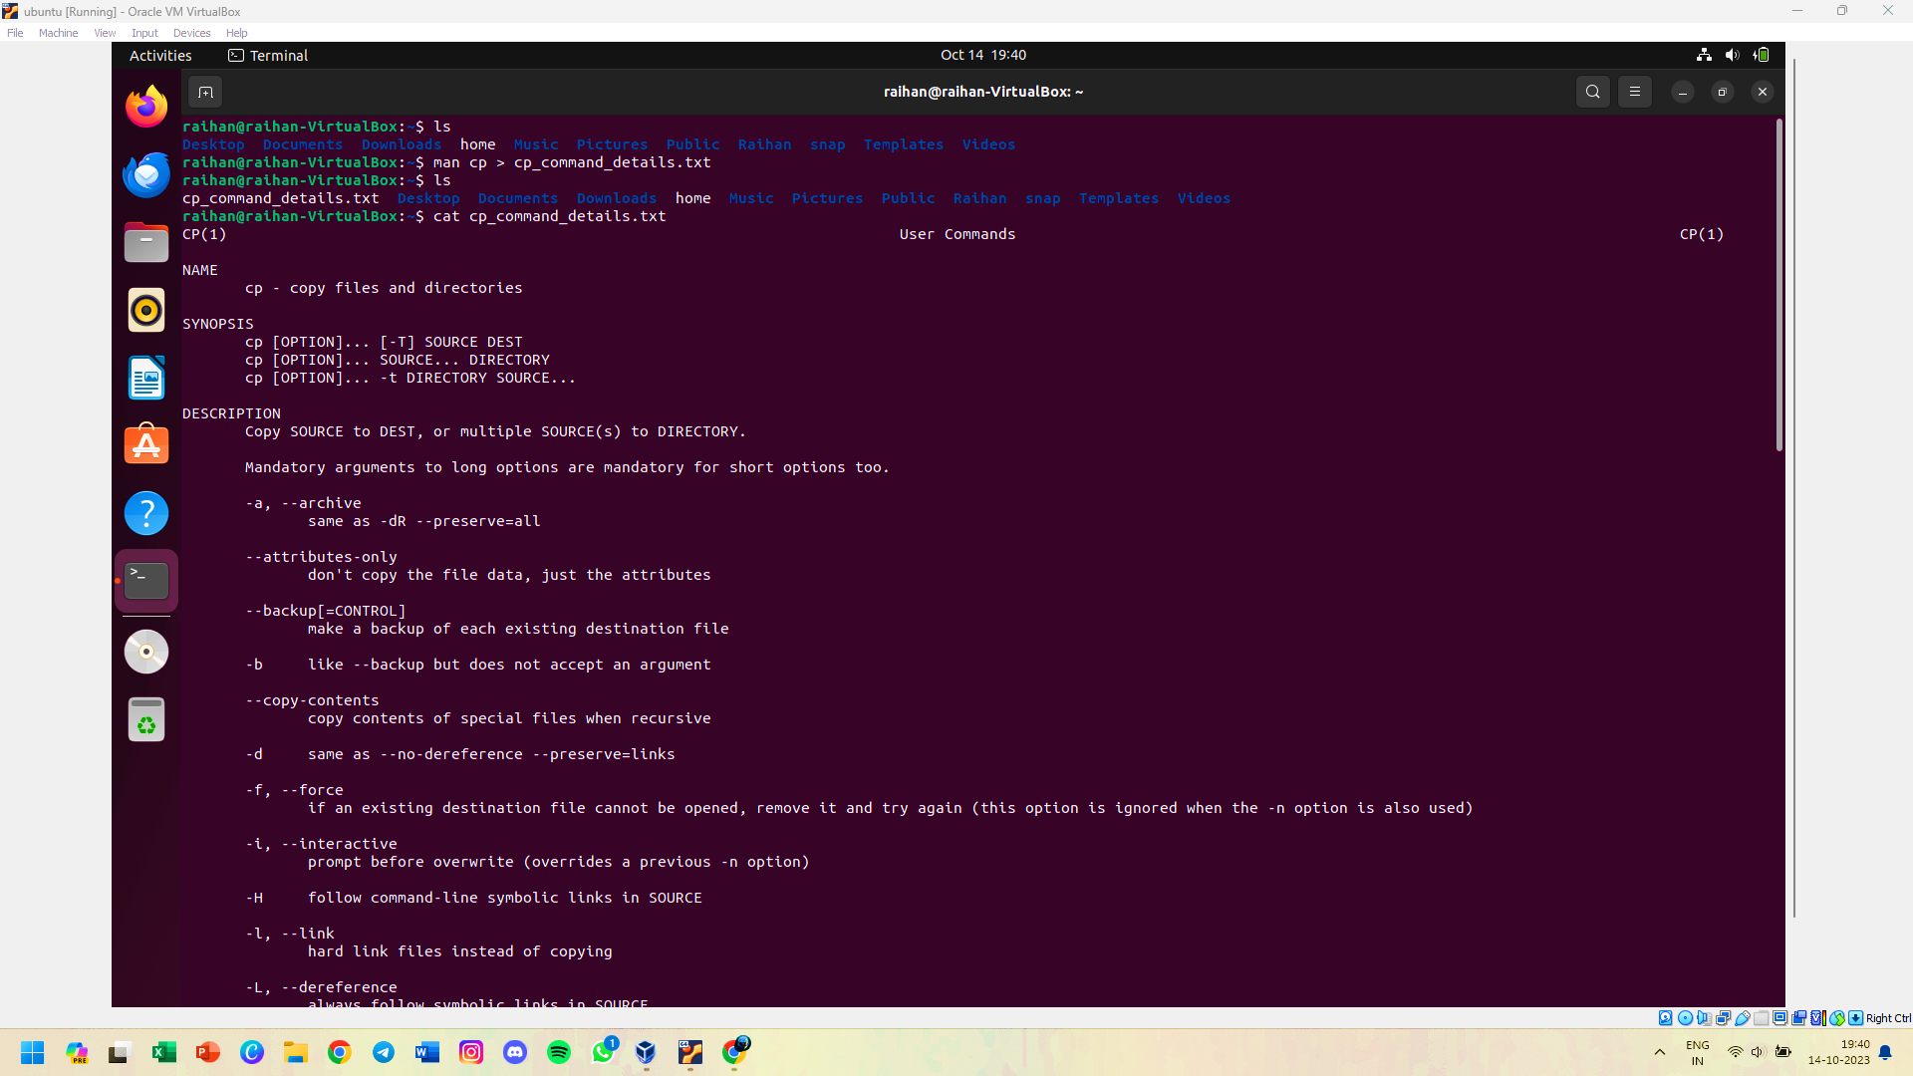

**11 Copy this file into the M10 folder**

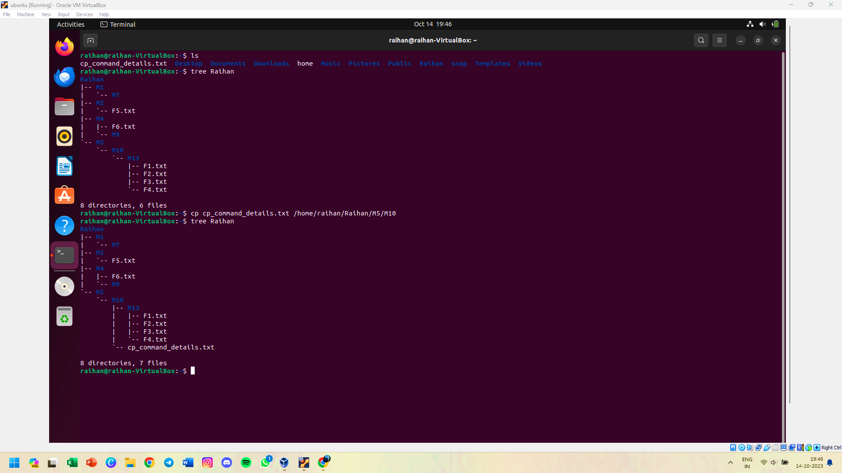

**12 Delete your whole directory structure using a single command**

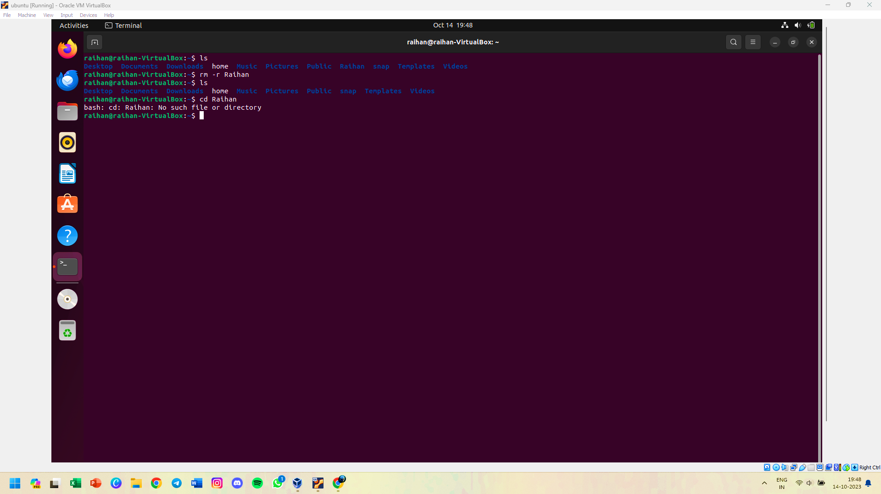

**13 Write a shell script to print addition & subtraction of two numbers**

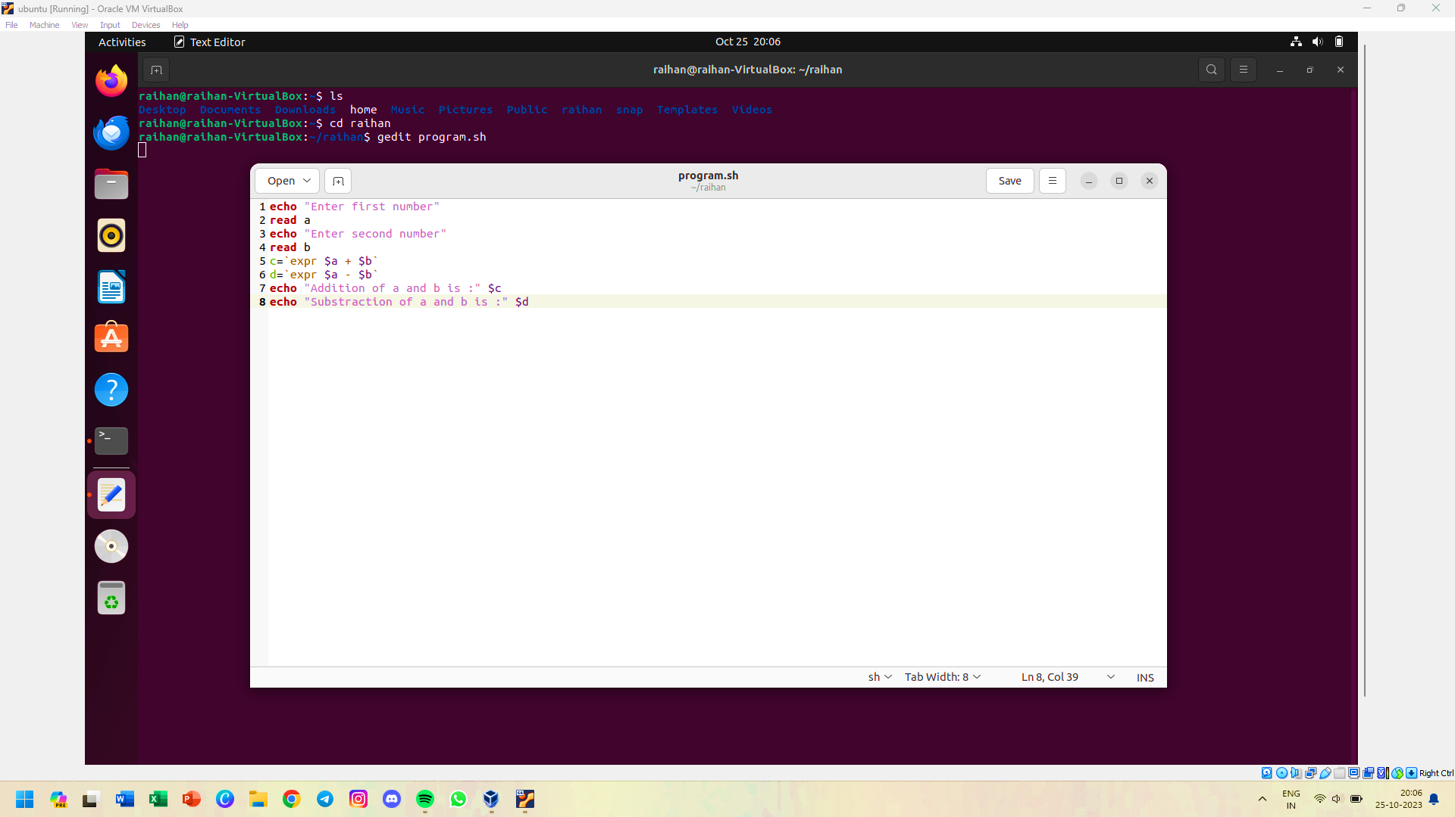

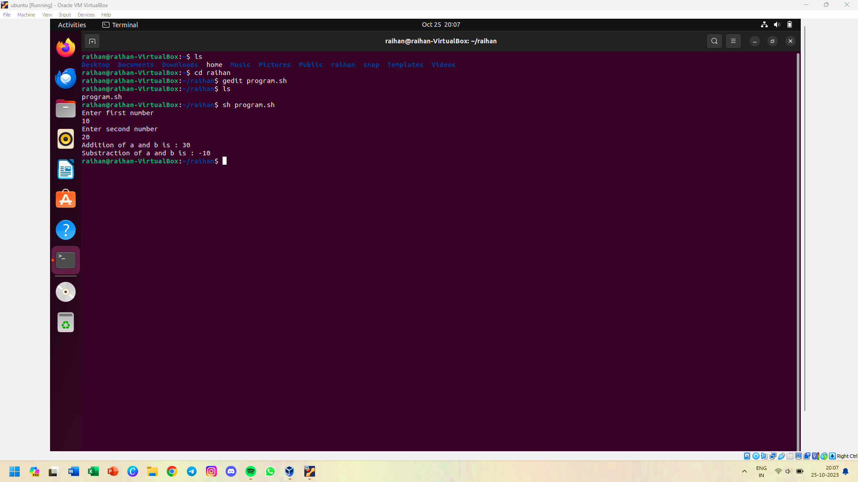

**14 Write a shell script to print multiplication & division of two numbers**

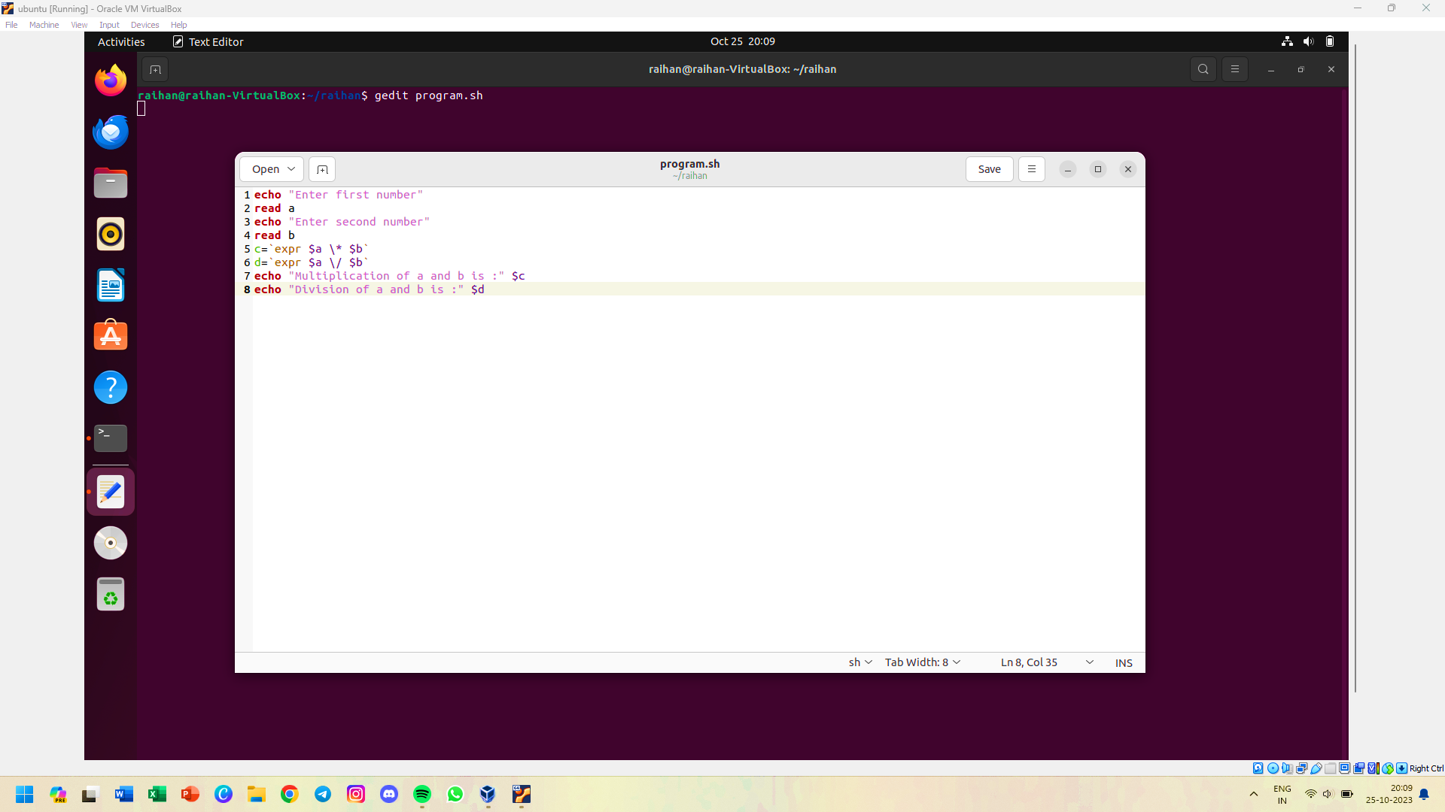

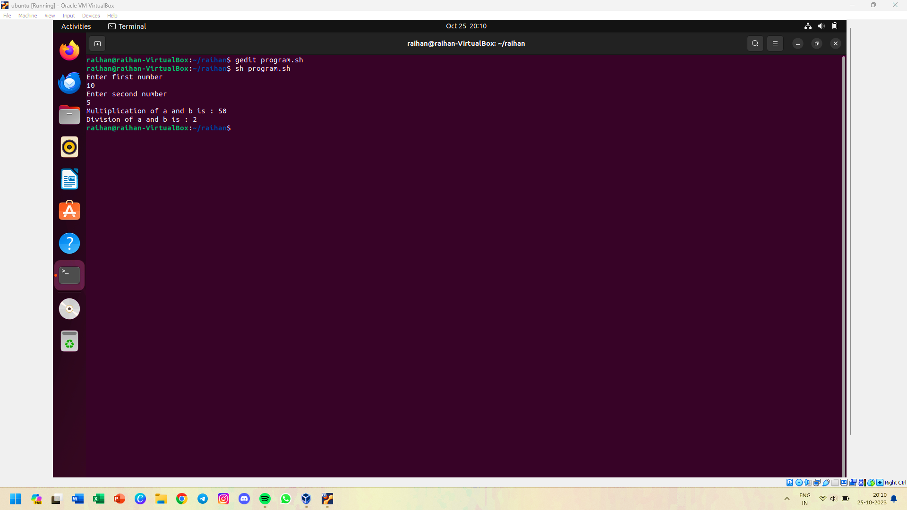

**15 Perform following function by shell script : D=b+c/a**

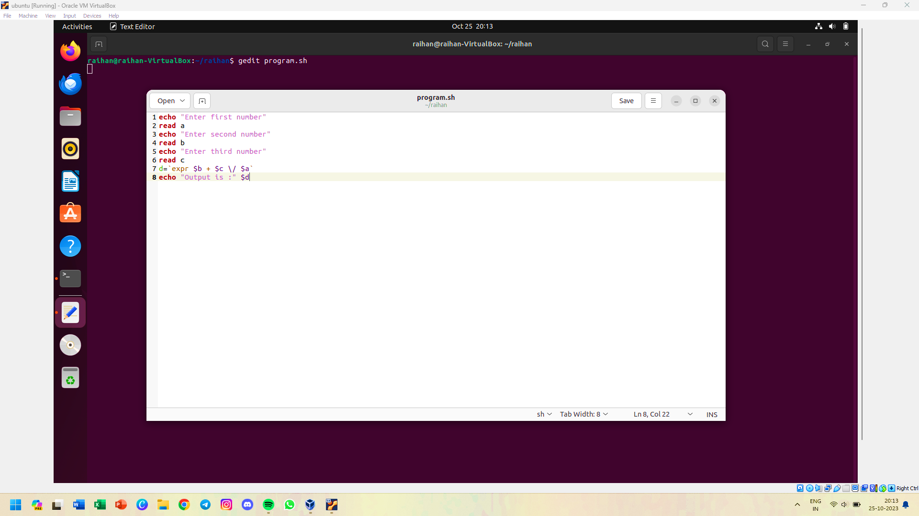

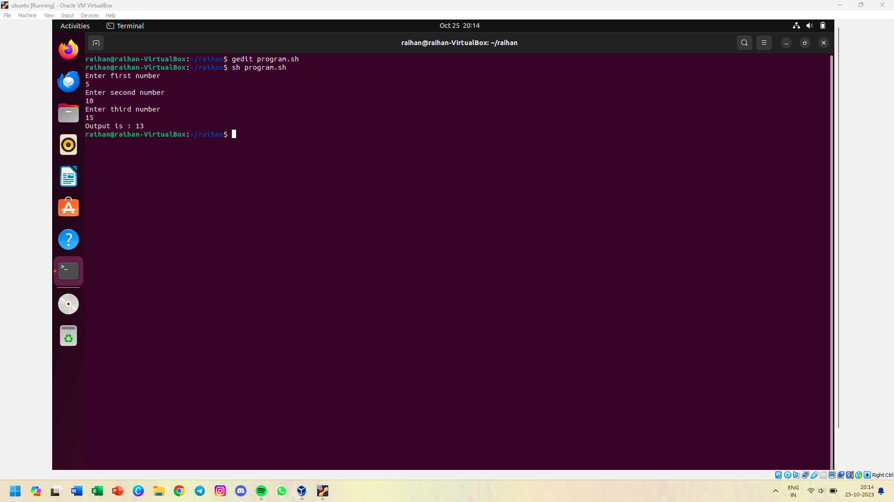

**16 Write the shell script to calculate average & percentage of marks entered by user**

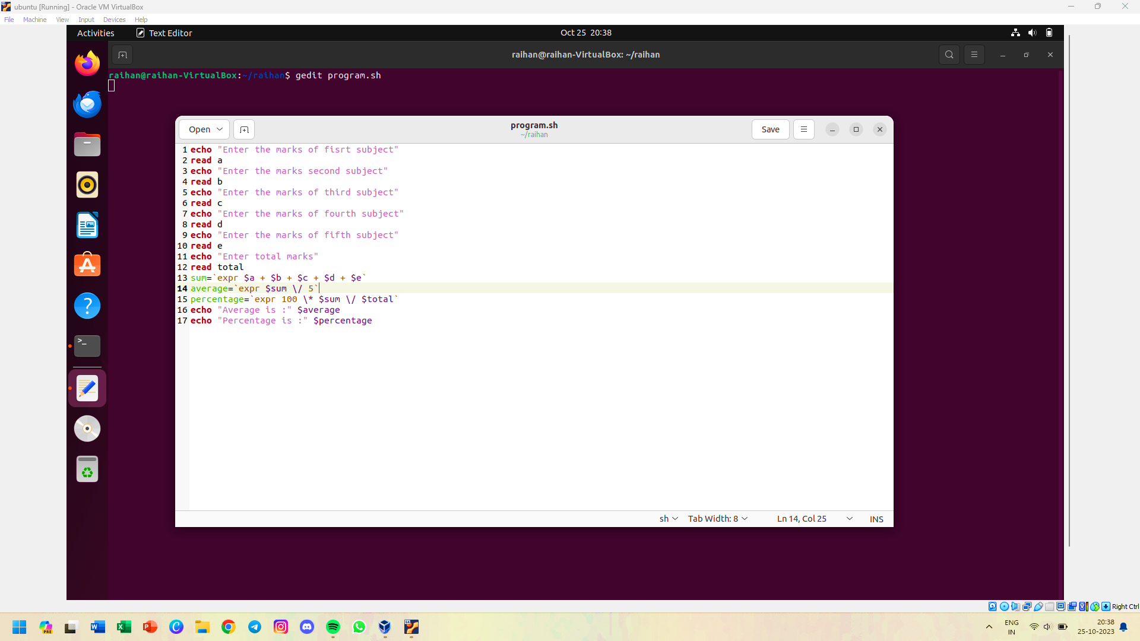

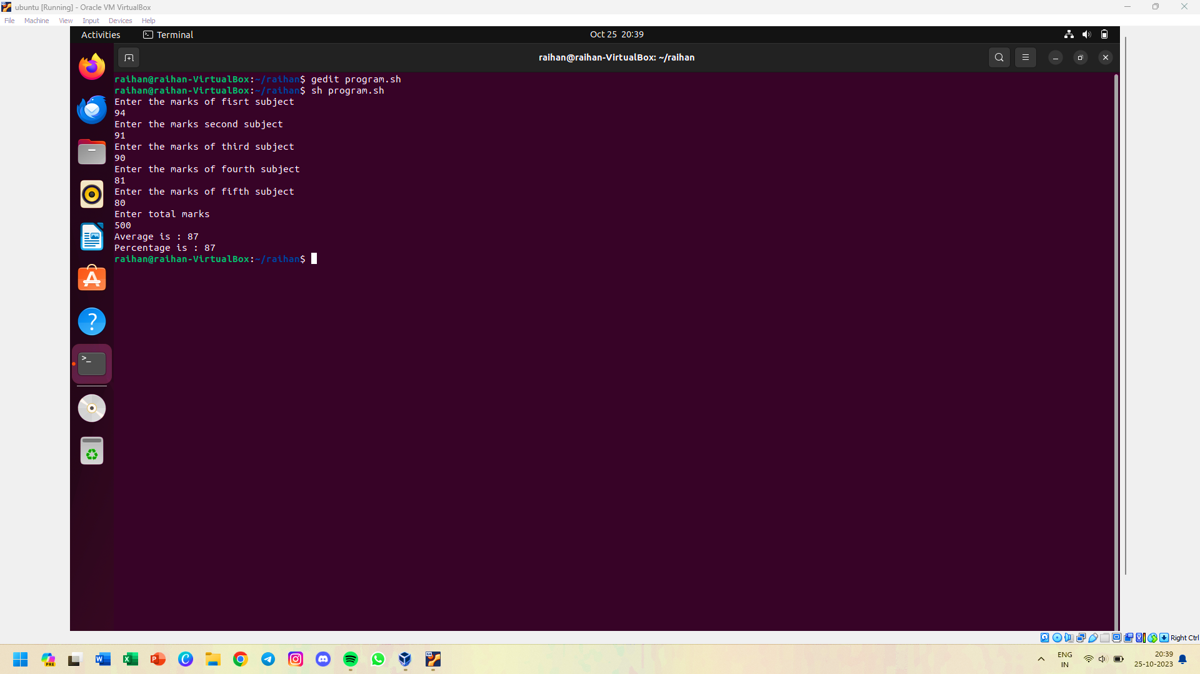

**17 Write a shell script to accept 3 numbers from user and find the largest among them**

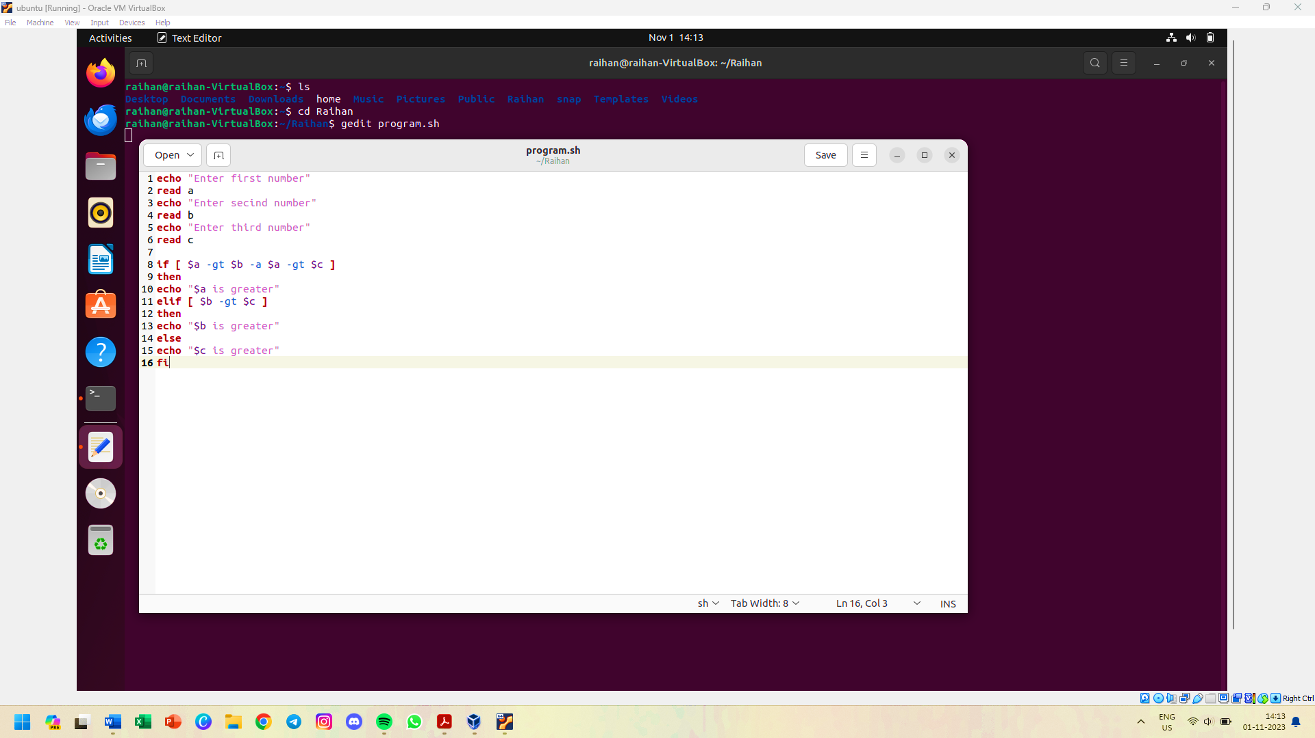

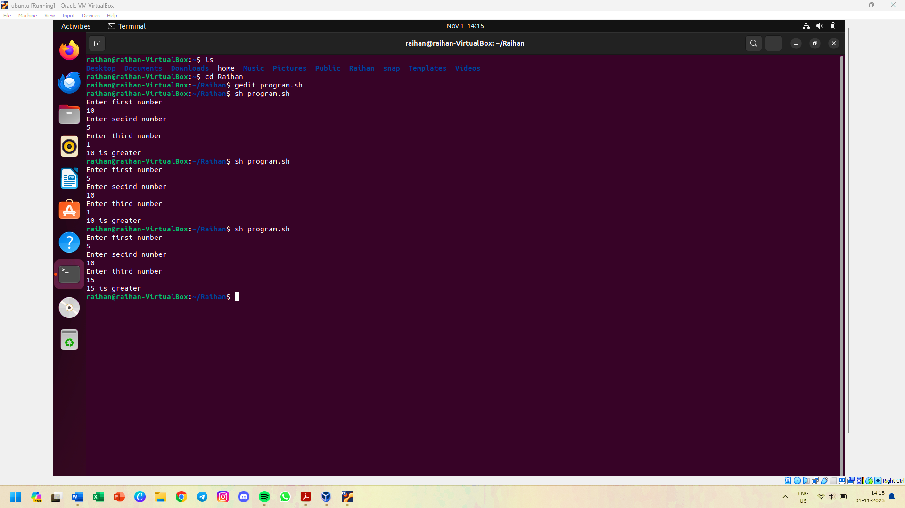

**18 Write a shell script to print if the number is odd or even accepted from user**

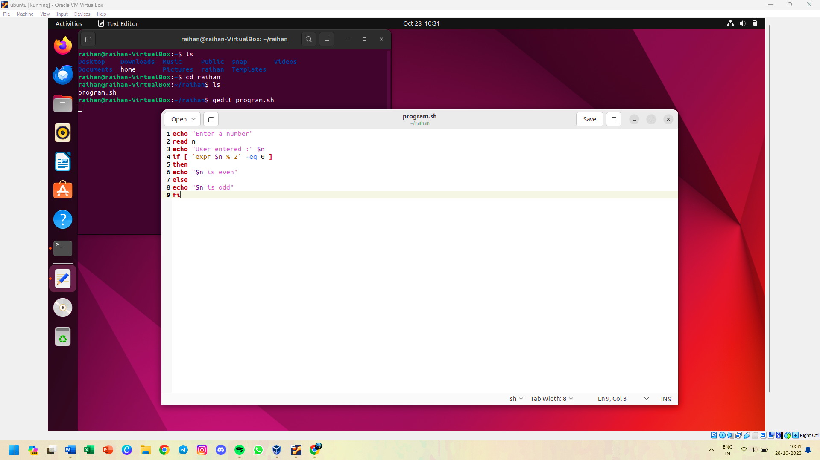

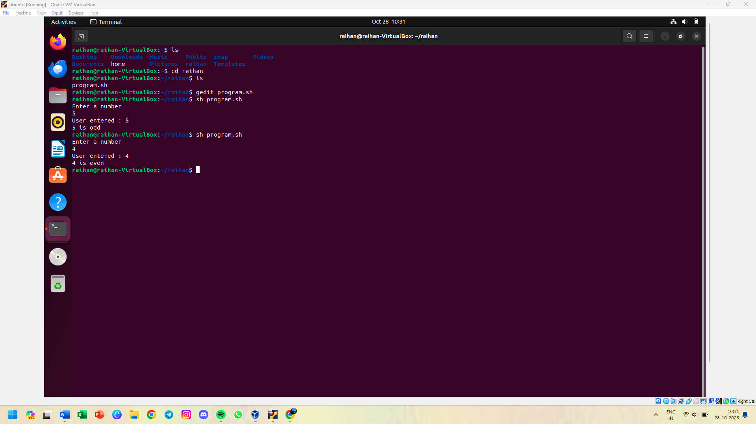

**19 Write a shell script that computes the gross salary of a employee according To the following rules**

**a) if basic salary is < 1500 then HRA=10% of the basic salary and DA=90% of basic**

**b) if basic salary is >=1500 then HRA=Rs 500 and DA=98% of basic**

**The basic salary is accepted from user**

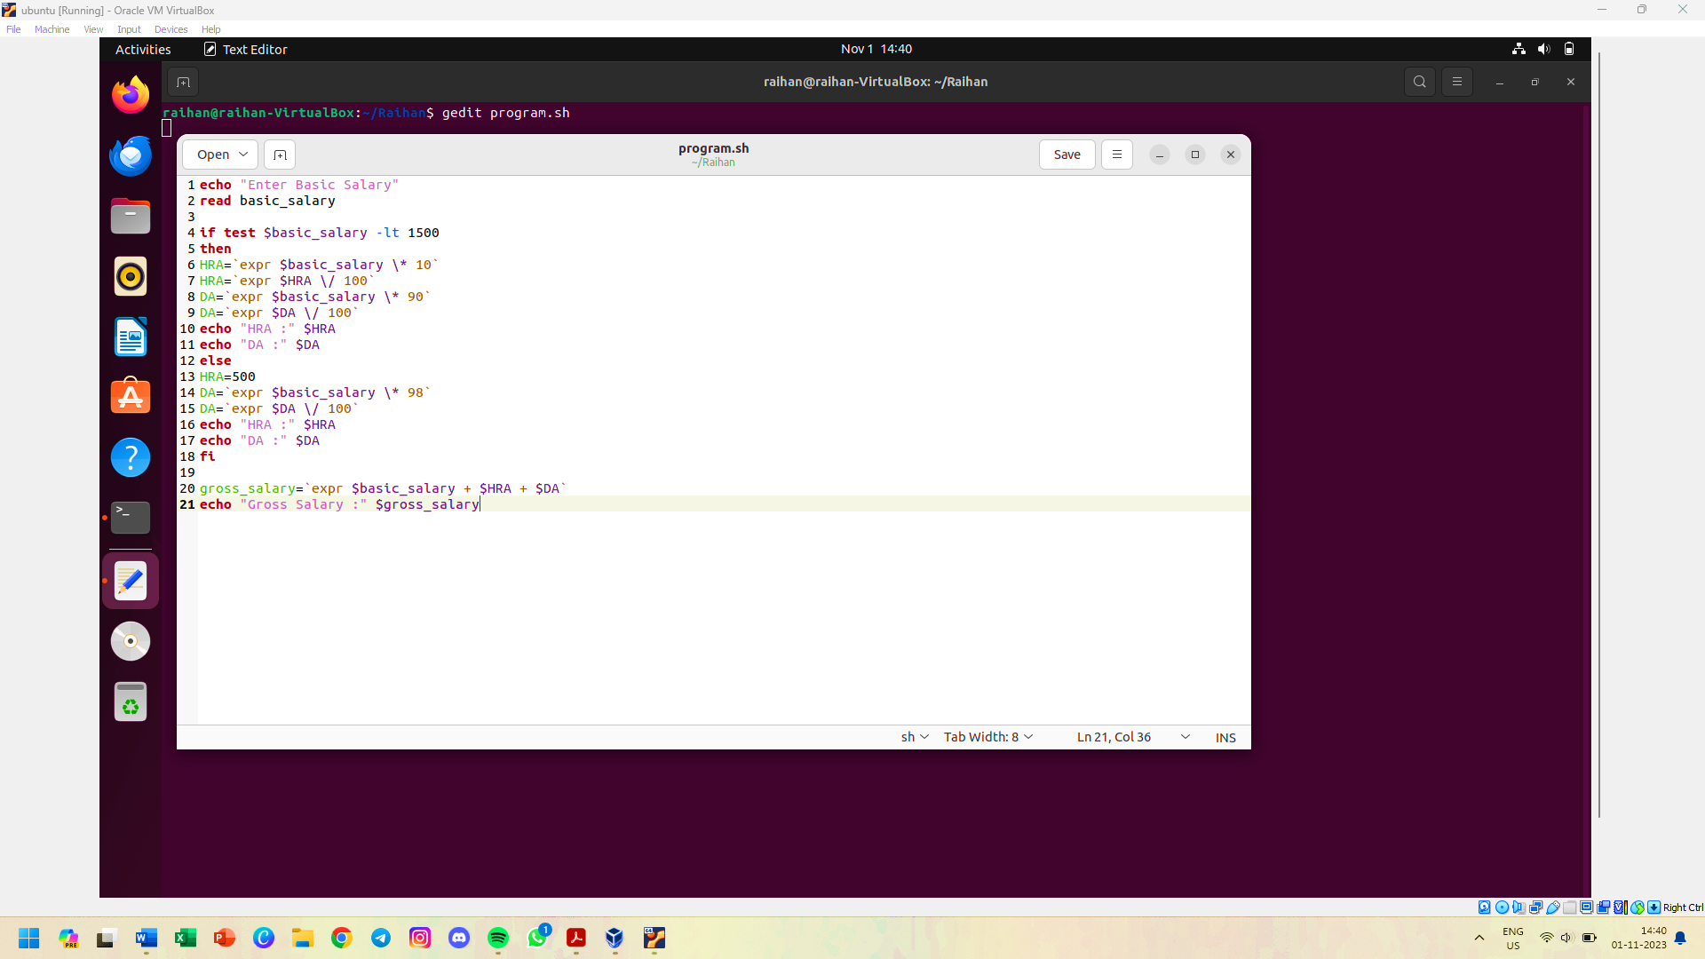

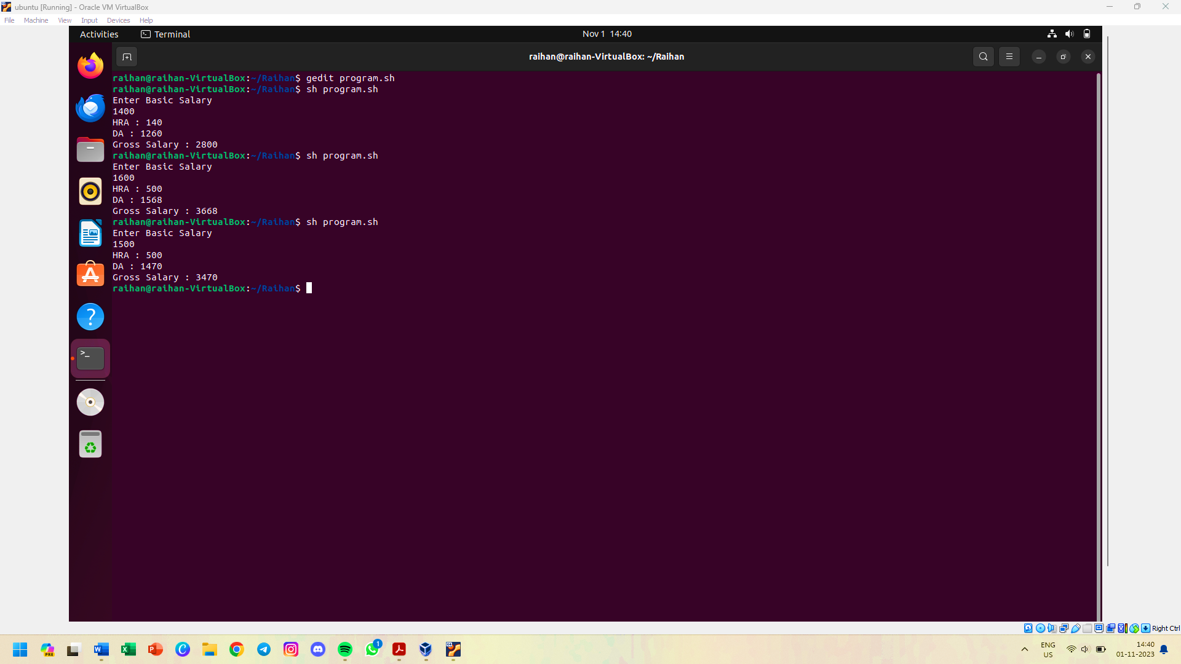

**20 Write a shell script to calculate the grade of student. Take 5 subjects into consideration.**

**Grade “O” if >= 90%**

**Grade “A” if >= 75% but less than 90%**

**Grade “B” if >= 60% but less than 75%**

**Grade “D” if >= 50% but less than 60%**

**Grade “E” if < 50%**

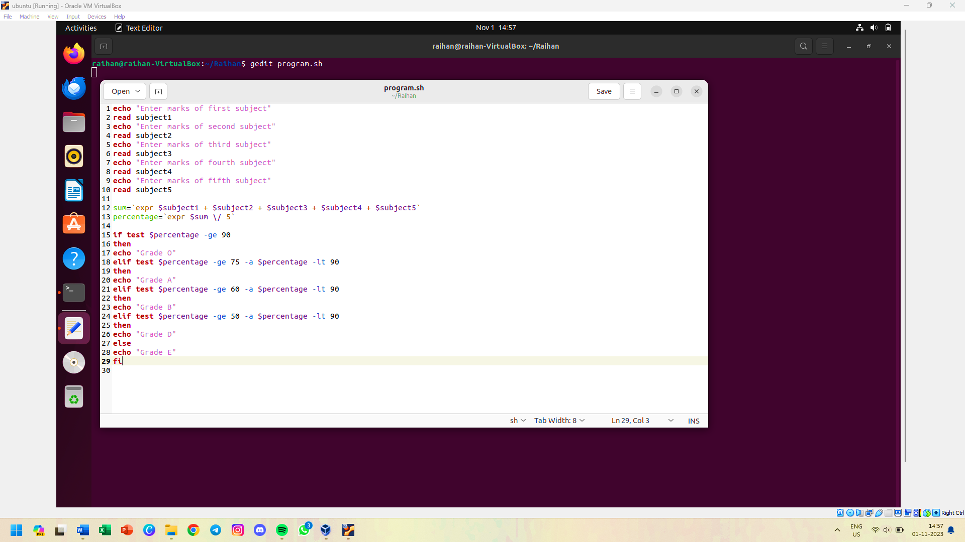

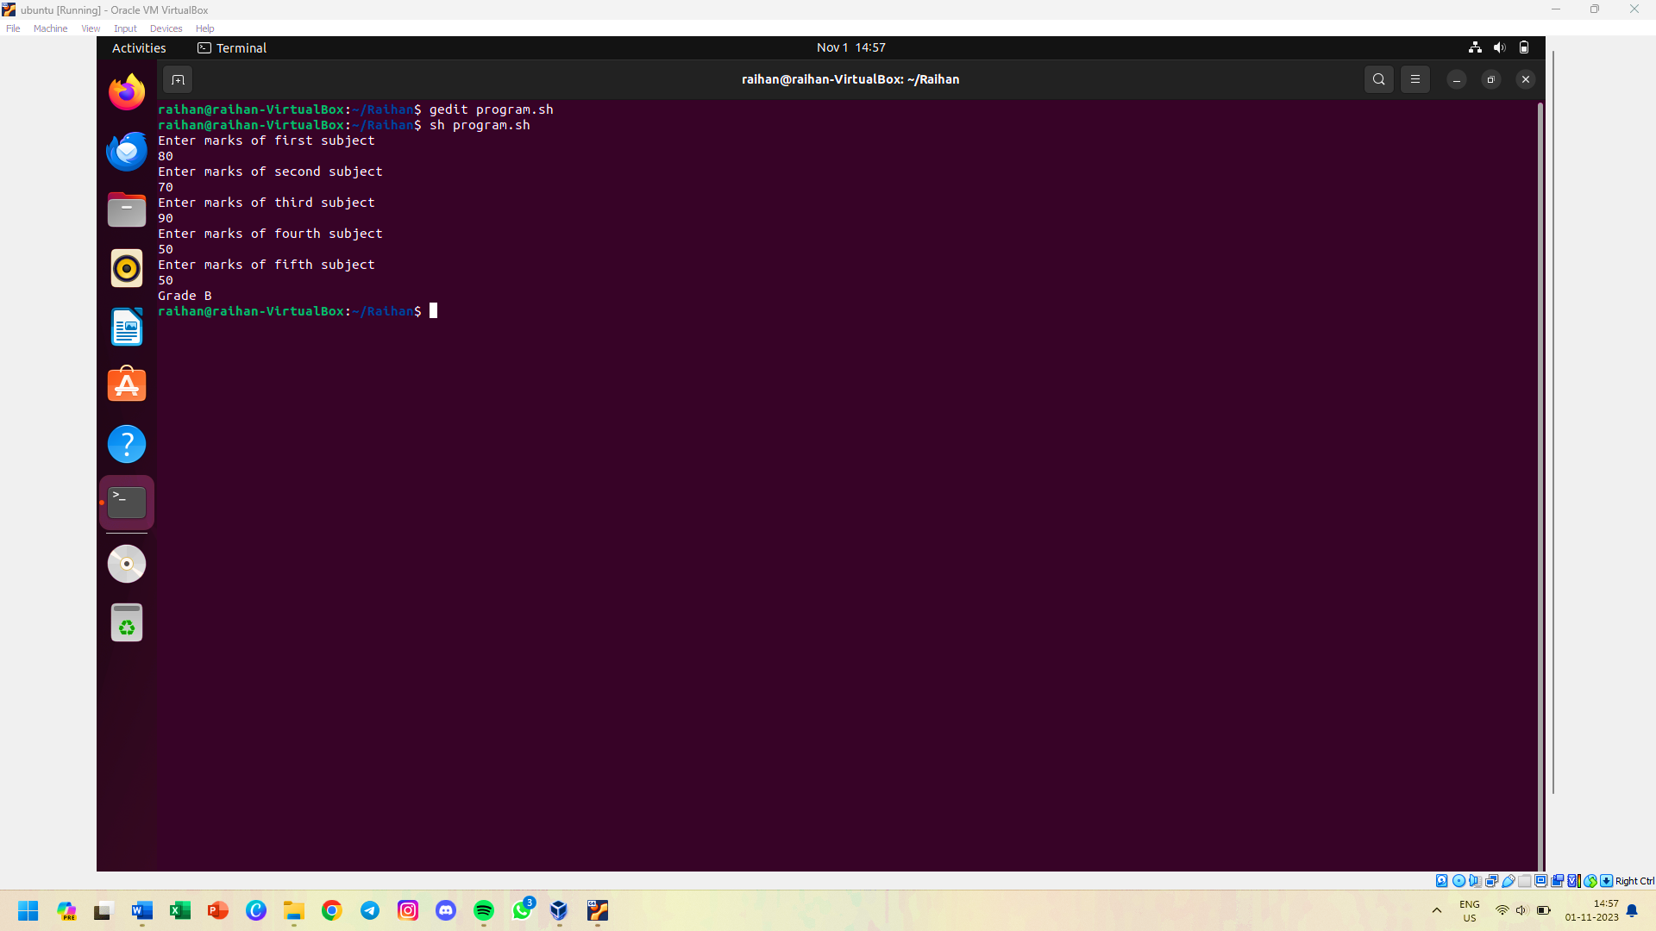

**21 WAP to print the Parent and Child process id in c and run it in Linux terminal**

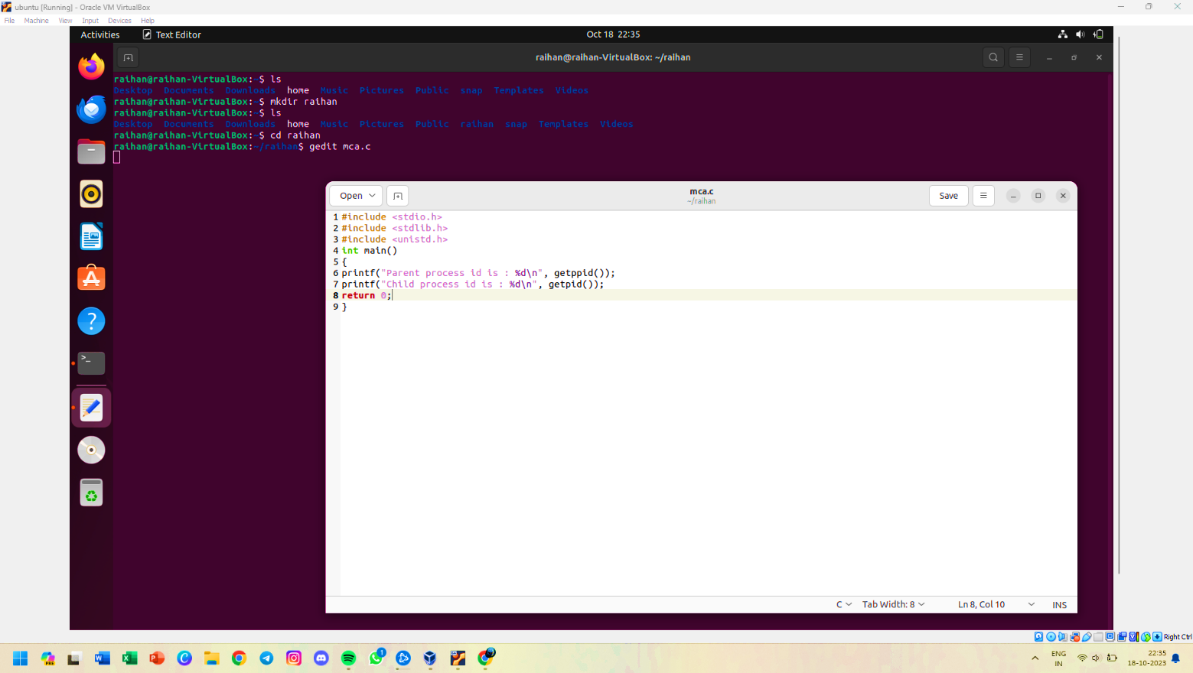

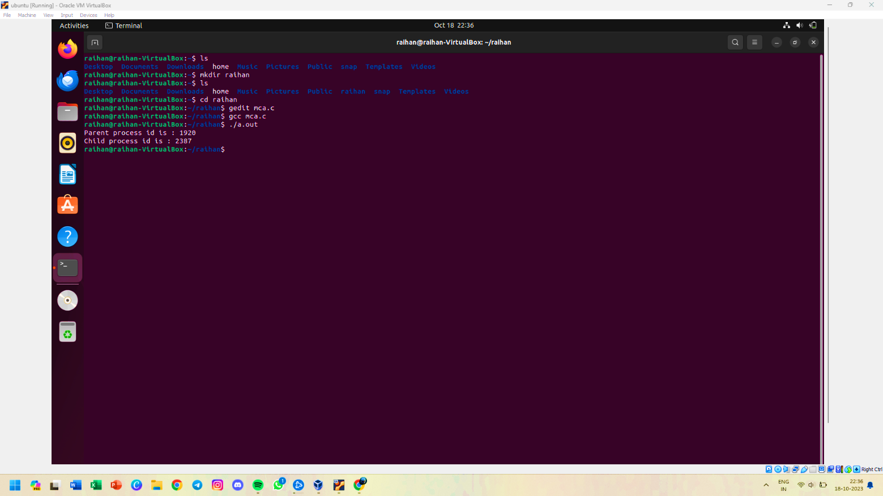

**22 WAP to create a process and check whether the process is created or not using if else statements**

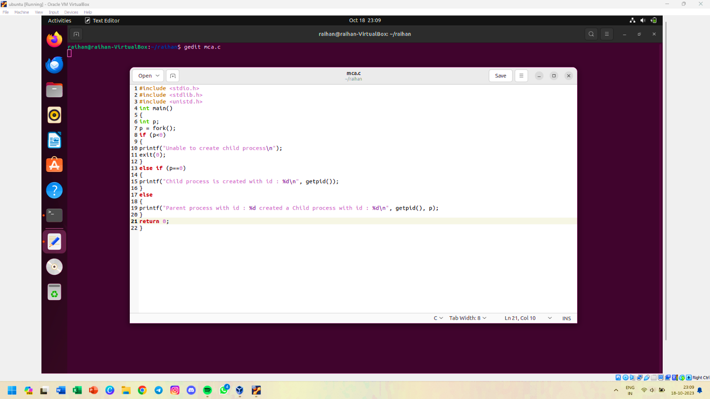

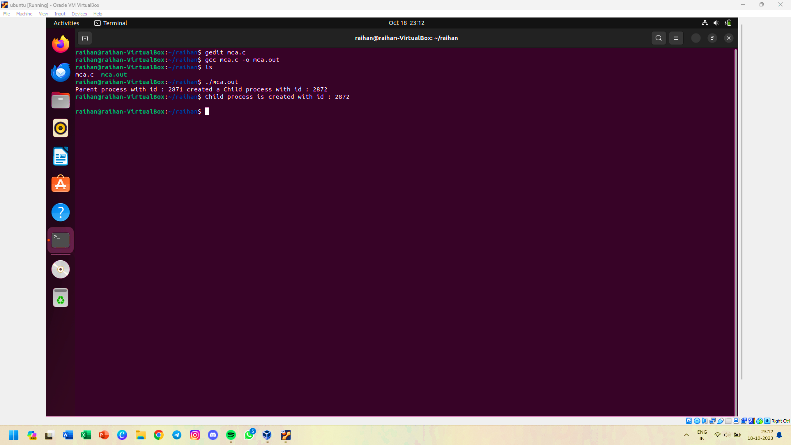

**23 Create a nested process using fork() command**

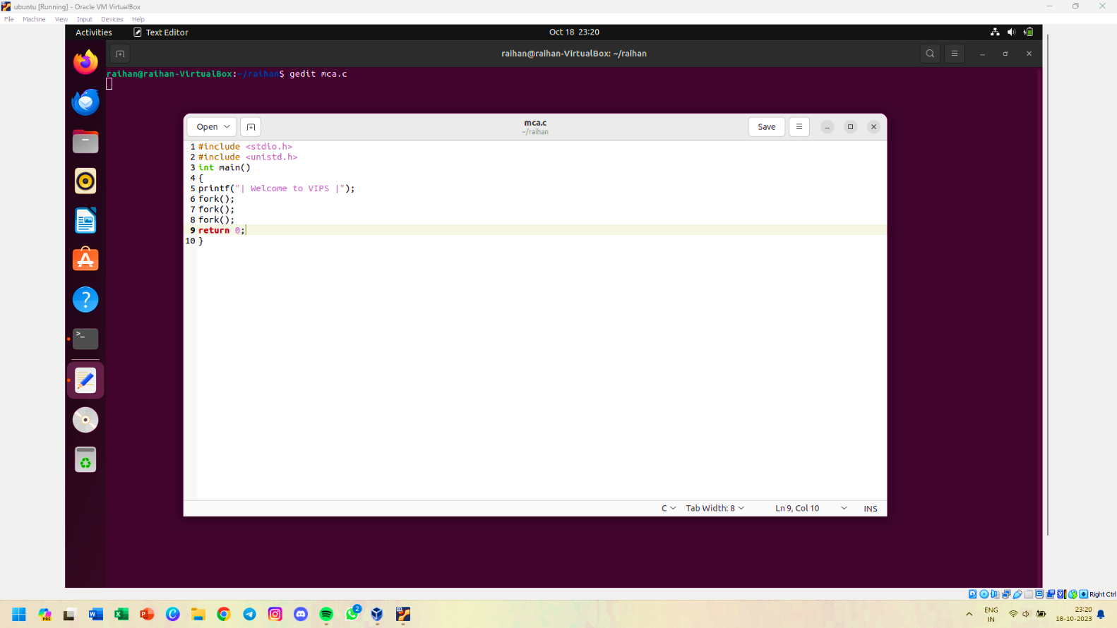

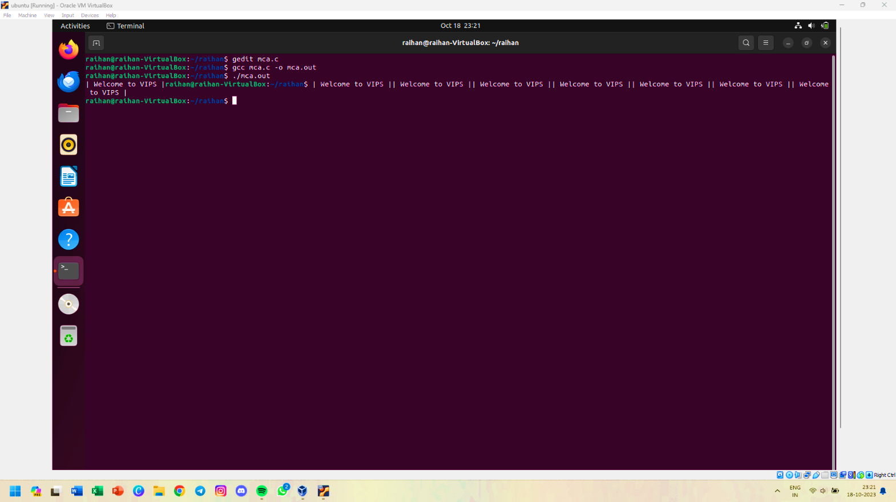

**24 WAP factorial of a number**

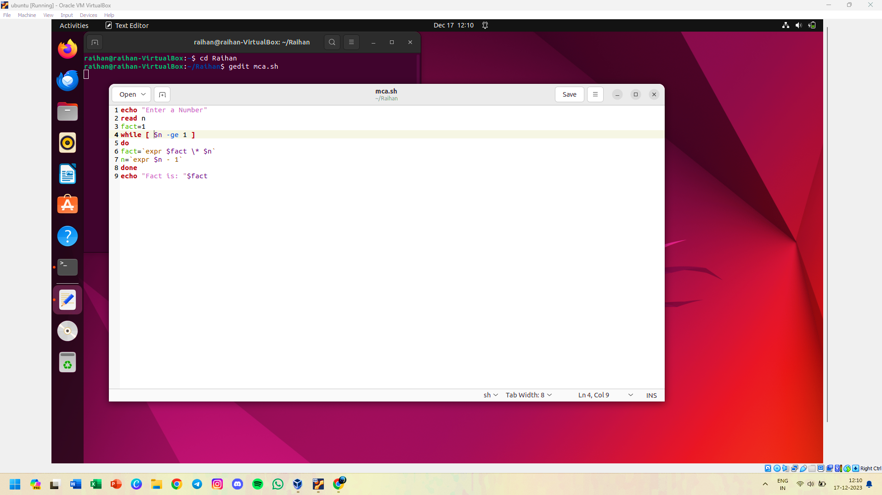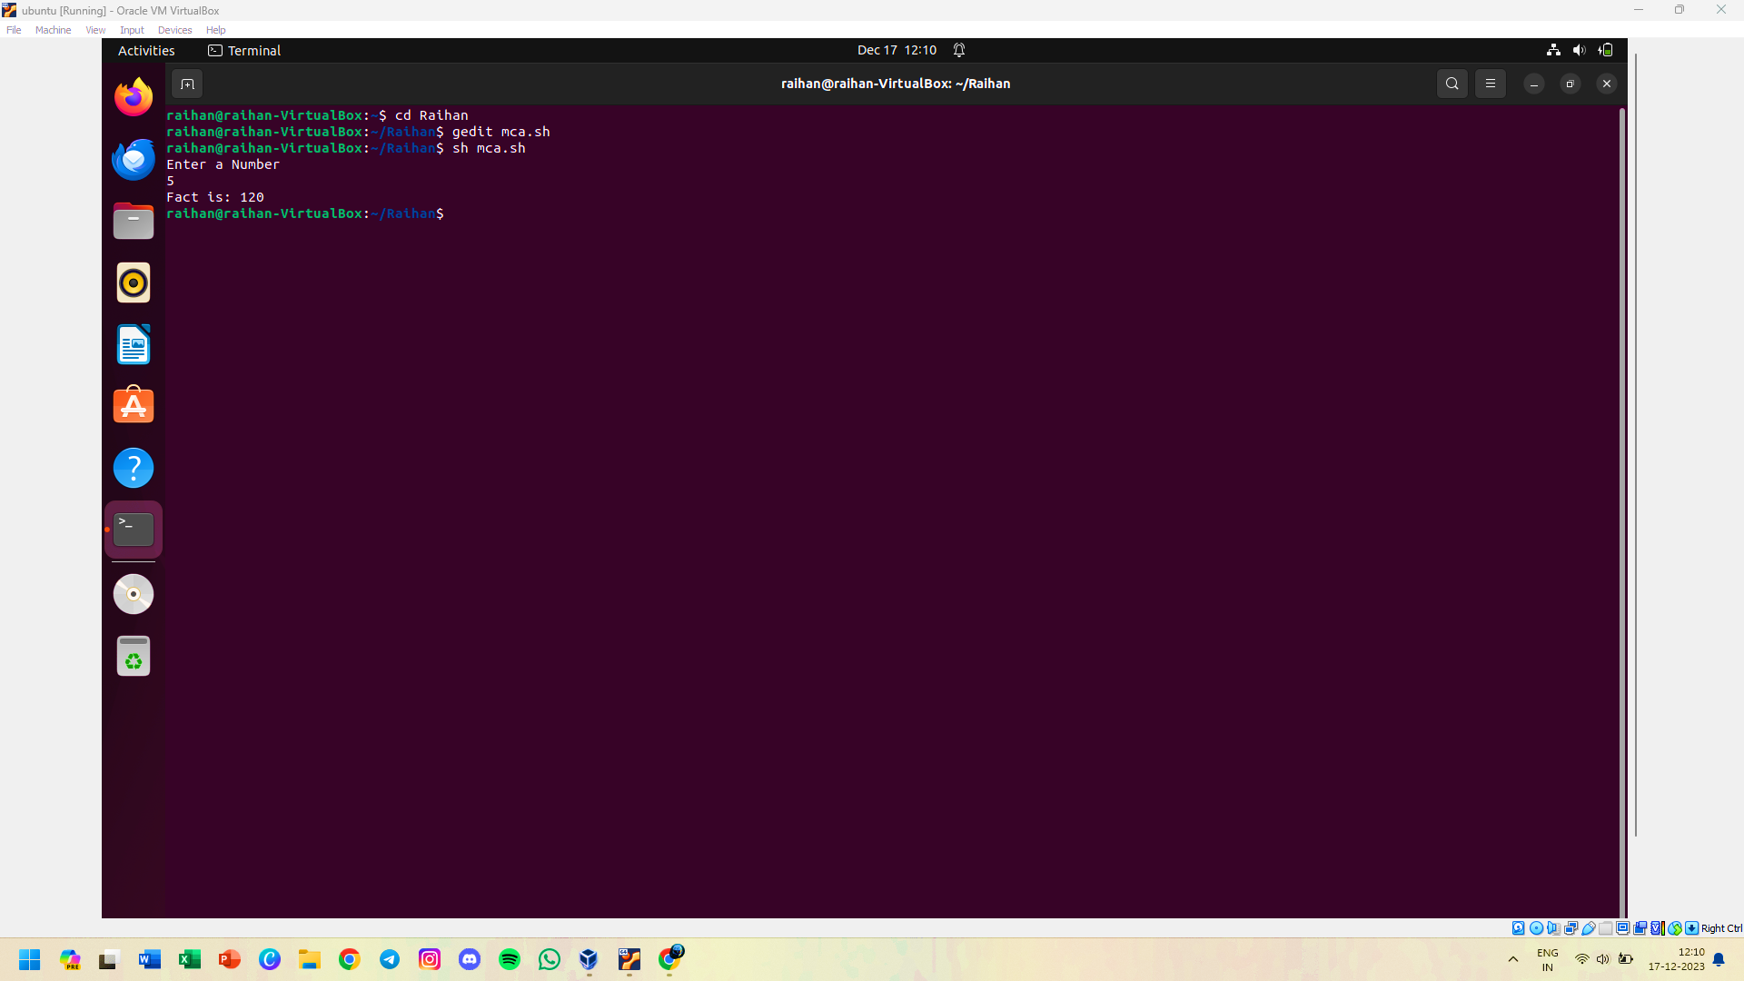

**25 WAP sum of first 10 natural numbers.**

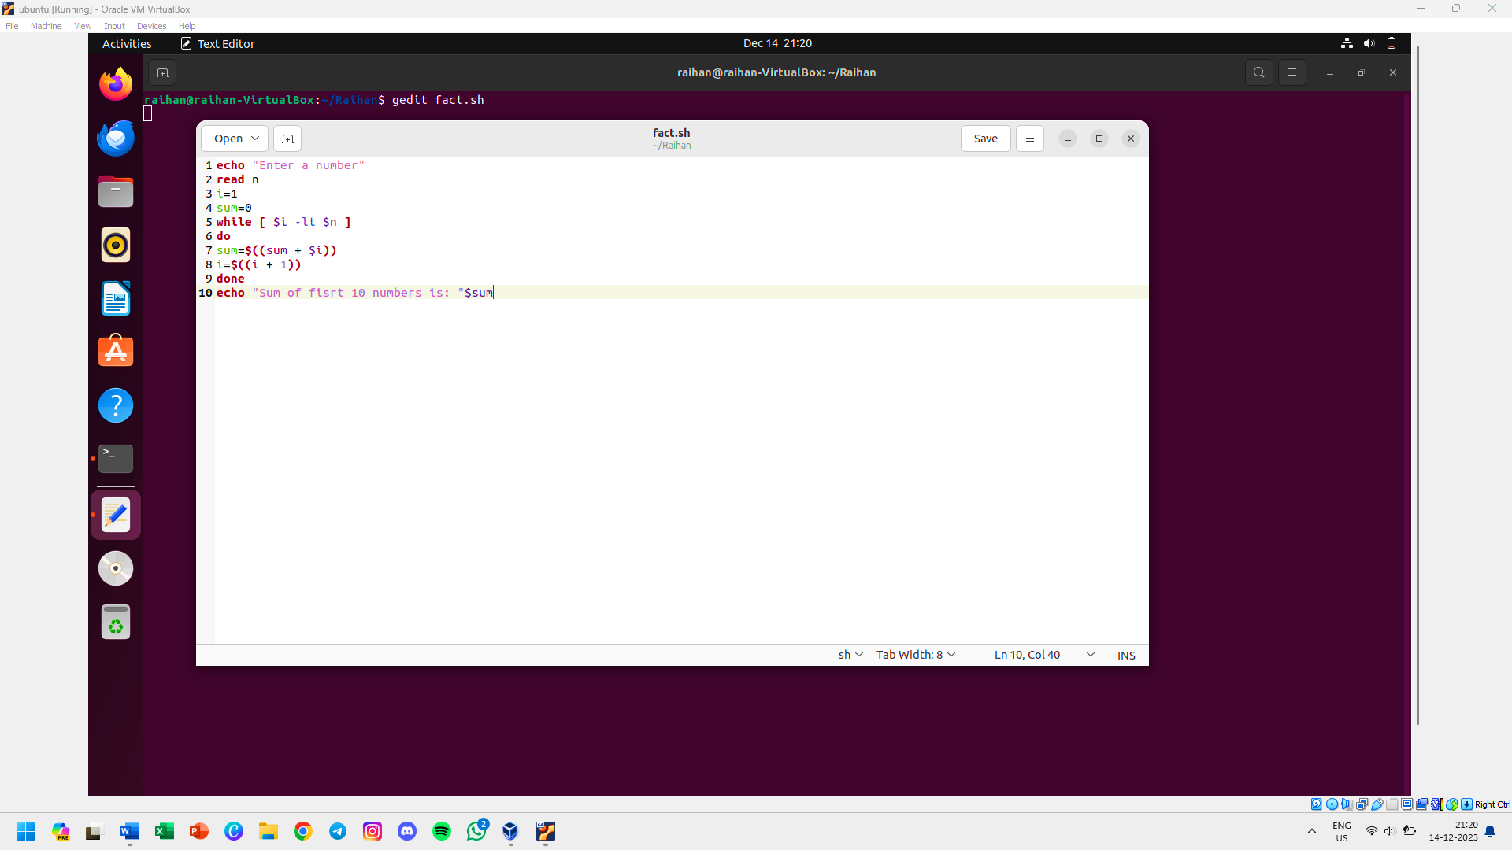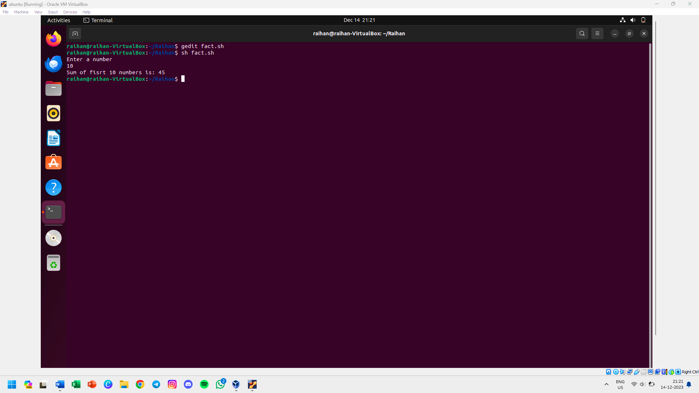

**26 WAP sum of first 10 input value.**

